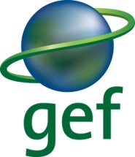 | 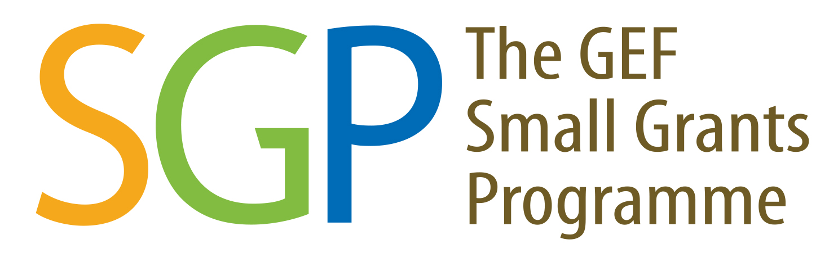  United Nations Development Programme  Global Environment Facility Small Grants Programme
Indigenous peoples Fellowship 2018

The Global Environment Facility Small Grants Programme (GEF/SGP) of the United Nations Development Programme in Nepal invites application from Nepalese citizen for the Indigenous Peoples 12 months Fellowship programme. The candidate should be a leader in the community; passionate about issues affecting indigenous peoples’ land, customs and environment; and interested to know more about how can s/he make sure his/her issues heard by a larger audience.

The Fellowship comes with these opportunities:
- Job placement with UNDP GEF/ SGP in Kathmandu valley,
- Regional and international training. and
- Participate in key international events on indigenous peoples.

The successful candidate is expected to link the SGP with the national indigenous peoples’ networks and issues.

Download and fill in the application form on the UNDP GEF/SGP website: www.sgp.org.np

Email completed form and send to gopal.sherchan@undp.org on or before 9 July 2018.

For further information please contact:
National Coordinator
UNDP Global Environment Facility Small Grants Programme (GEF/SGP)
Bhanimandal Chowk, Ekantakuna, Lalitpur, Tel: 5000119
Mailing Address: GEF/SGP, UN House, Pulchowk, P.O. Box 107, Kathmandu
E-mail: gopal.sherchan@undp.org Web: www.sgp.org.np and www.sgp.undp.org

